COSC2640​ ​Cloud​ ​Computing​ ​2020-​ ​Assignment​ 2

RMIT​ ​University

Weather​ ​Analytics

Students: Aimerance Ndayisaba(s3722355), Aqram Abdul Rahman (s3547091)

Abstract

As time moves the way we do thing has evolved including information technology industries, we are now more focused on host our information/data in the cloud which have made it easier for us to access the data when we are anywhere or using any computer. It was provides storage, database, security, analytical features, network, application services and many more hence making it coinvent to use. In addition to all those features ​Cloud​ ​providers​ ​exposed​ ​APIs​ ​that​ ​for​ ​the​ ​first​ ​time​ ​allowed​ ​full infrastructure​ ​automation,​ ​allowing​ ​infrastructure​ ​resources​ ​to​ ​become​ ​something​ ​that​ ​was interacted​ ​with​ ​directly​ ​from​ ​code.​ ​​​This​ ​ability​ ​to​ ​access​ ​“infrastructure-as-code”​ ​has fundamentally​ ​changed​ ​the​ ​concept​ ​of​ ​infrastructure,​ ​and​ ​allowed​ ​it​ ​to​ ​become​ ​a​ ​dynamic extension​ ​of​ ​applications,​ ​rather​ ​than​ ​the​ ​static​ ​resource​ ​on​ ​which​ ​code​ ​is​ ​run. Its due to this ​ ​aspect​ ​of​ ​Cloud​ ​computing, ​ ​the​ ​automation​ ​of​ ​infrastructure, ​ ​that​ ​we ​have chosen​ ​to​ ​focus​ ​our​ ​assignment.

Introduction

The​ ​purpose​ ​of our project is to use cloud services to host and analyse the past and present temperature of Queensland Australia. We use the information that is publicly available at OpenWeatherMap from (<https://openweathermap.org>) website as the data source​ ​for​ ​our​ ​application. The cloud platform we choose is Amazon Web Services.

OpenWeatherMap provides an API that allows access to current weather data for any location over 200,000 cities. It’s current. Its current weather data is frequently updated based on global models and data from more than 40,000 weather stations. The date is available in JSON, XML, or HTML format, this makes it easier for us to use it as the data source for our application since we will be using HTML.it is also convenient since it provides a free subscription.

Developer​ ​Guide​ ​and​ ​User​ ​Manual

This Guide and user manual include how to set up the environment, how to build the website, how we gathered the data, how to access the website and how to use the website.

**Choose an Amazon Machine Image (AMI)**

Step 1: Creating AWS EC2 instance

We first created the key pair:

* Open Amazon EC2 console, go to the navigation bar, click on key pair, then choose create key pair, gave it a name, saved using Putty to convert .pem into .ppk.
* Start puTTYgen,





* After choosing how to save it click create key pair. Named it Linux
* Now that the key pair is created and saved, go to AWS services, click on EC2, choose launch instance.





* In step 1: choose an choose an Amazon Machine Image (AMI), and we choose Ubuntu.



* Step 2: configure instance type, we used the default, which is a free one , the t2.micro.



* Step 3: Configure Instance Details:
  + Network: vpc-ccb0b3b6
  + Subnet: no preference







* Add storage



* Add tag, our tag name is Weather



* We leave the rest of the settings as default



* Review the instance





* Used the key pair we created



* Then launch the instance



* Make sure that is running



Step 2: Connect to our Virtual machine Instance

* Since we are using windows we used PuTTY to ssh the virtual machine.
* Click Open to start the PuTTY session.
* PuTTY displays a security alert dialog box that asks whether you trust the host you are connecting to.
* Click Yes. A window opens and you are connected to your instance.



* Now we customise the VM instance.
  + Install JDK



* + We installed, update, and start JDK using the following commands











Step 3: creating a website

To write the source code for our website we used w3schools, the language we use to write the source is PHP which made easier since the API used is also found in PHP language. Hence, we are able to get the data from OpenWeatherMap. We also used js to able to navigate through different pages, used CSS for the design to give the website a descent look and used for our header and footer.

Step 4: Data​ ​gathering using API

After doing some researching on how we would obtain data for our weather web application we decided to use public API since other ways of data scrapping were being a bit to difficult to use. An API (An application program interface) is a set of routines, protocols, and tools for building software applications. Additionally, APIs are used when programming graphical user interface (GUI) components. The public API provide data that web developers could use on their websites.

OpenWeatherMap provides a free subscription. To be able to use their date you sign up for a subscription first, then we login, click on current weather and forecasts collection , get API key and Start. Then we get sent the API key to the email used to login.





After getting the API key, we used the URL for API provided by OpenWeatherMap and we also included the key we were given to be able to view the date into our php code.

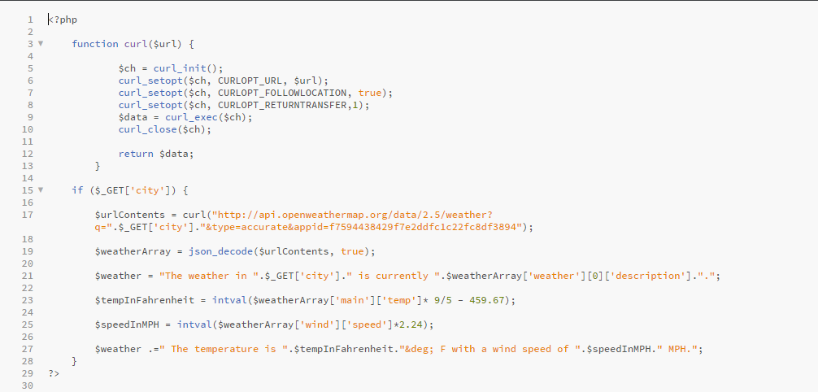

This code is used to show what we will be getting with GET method from the openweathermap api to get the current weather.

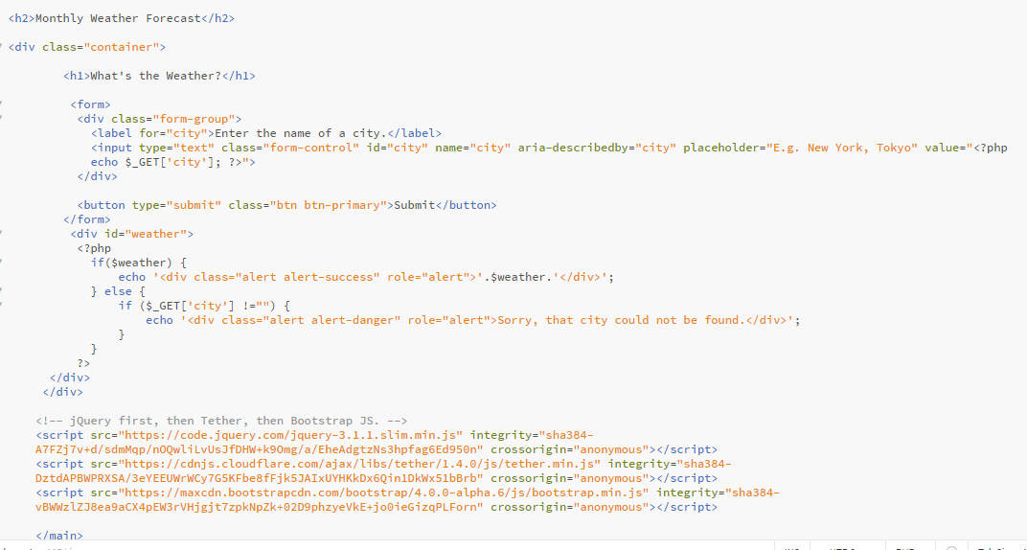

This code is used to read what we will get from the JSON file and display into our website

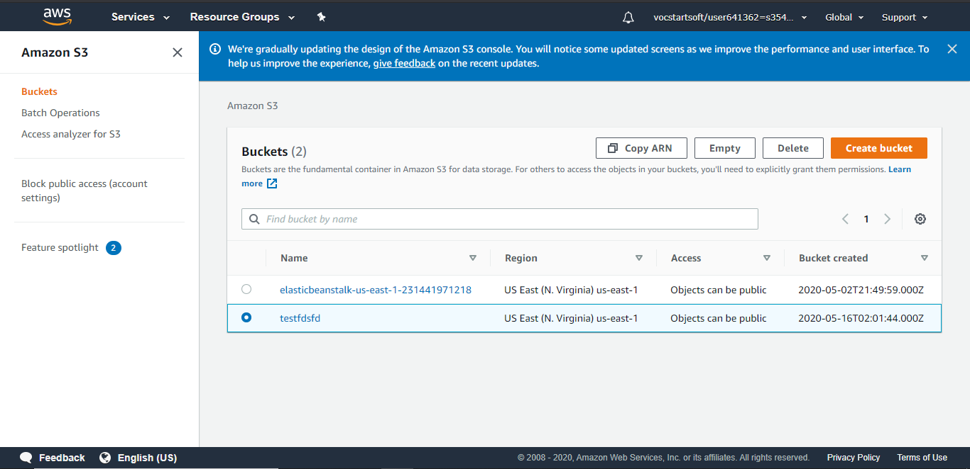

We got to our s3 bucket and create a bucket

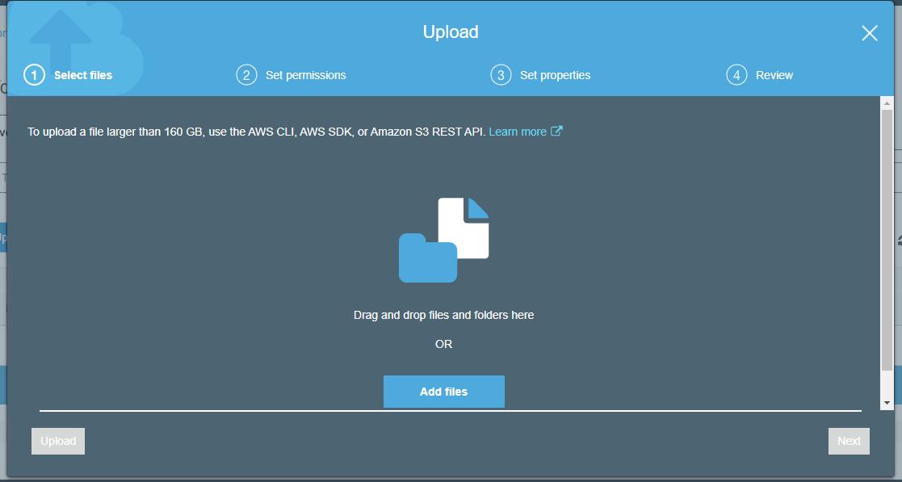

We upload our files

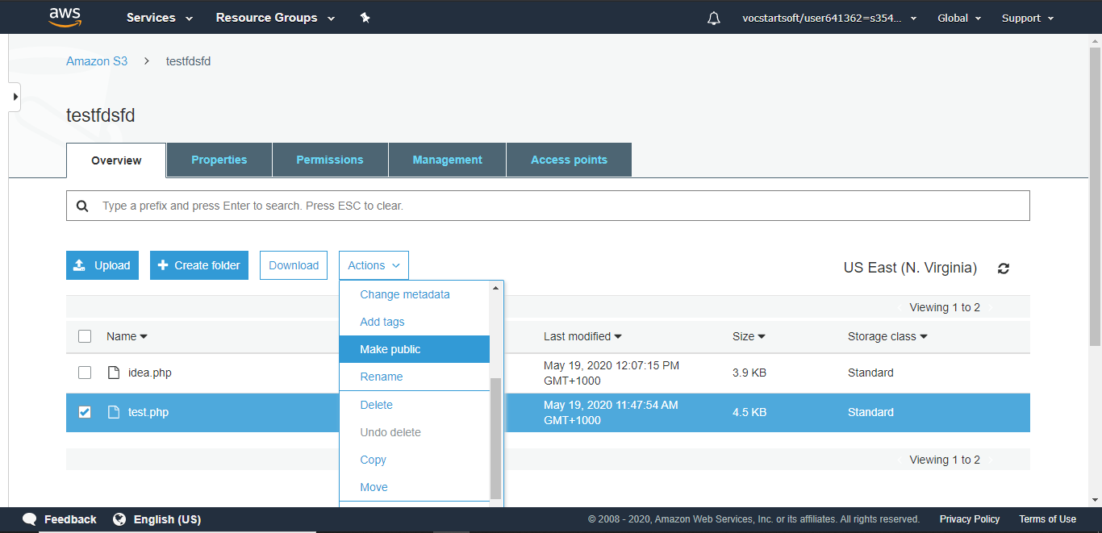

We make the files public so we get access to the files from the EC2 instances

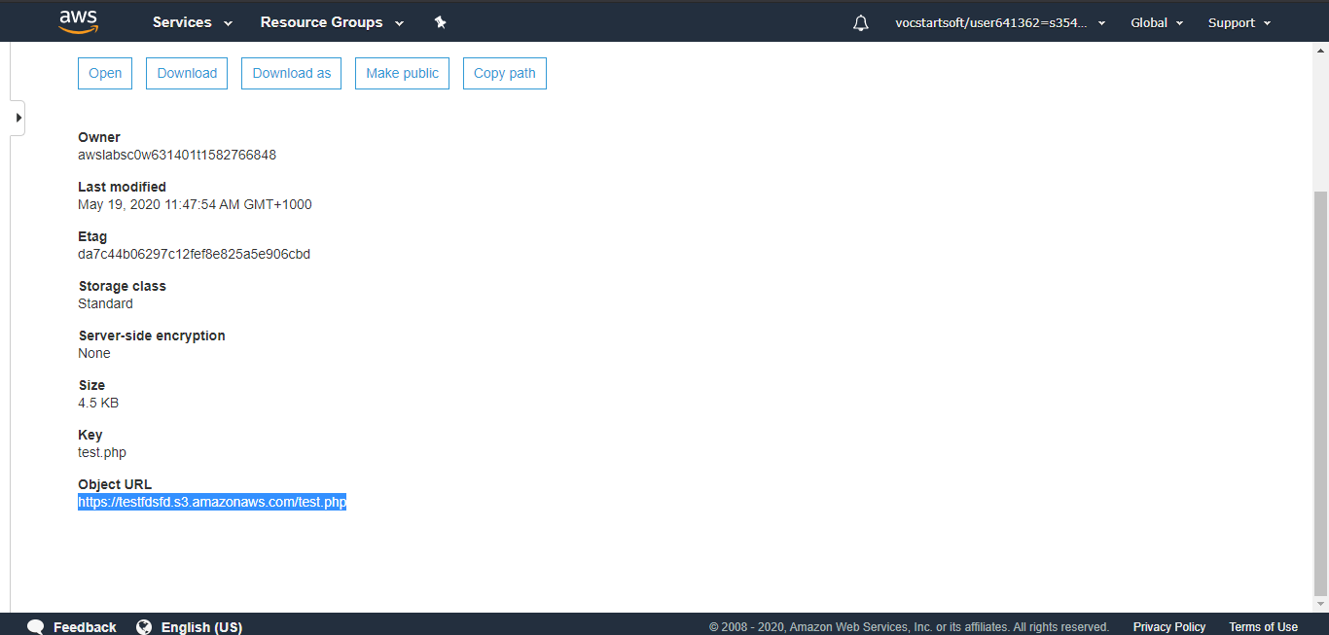

We copy the object url of the files so we can upload them with wget to the terminal

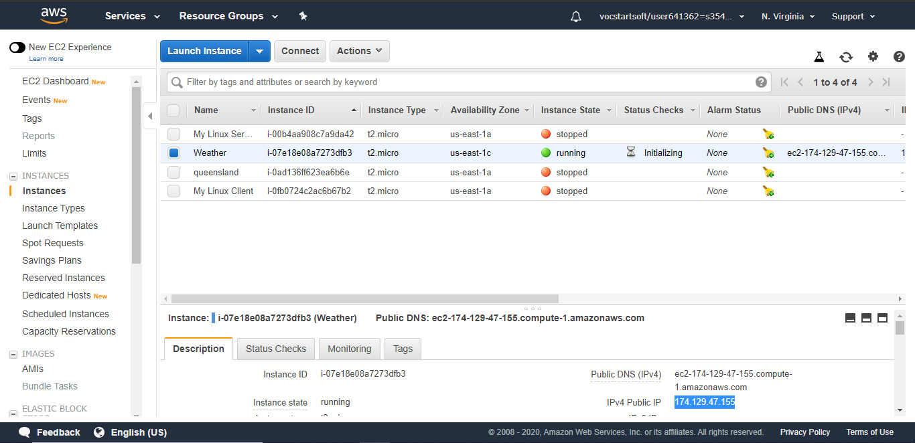

We run our instance machine

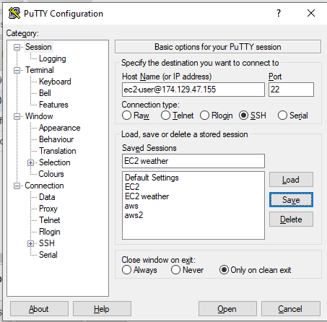

We put the ip address of the instance to connect to it via putty

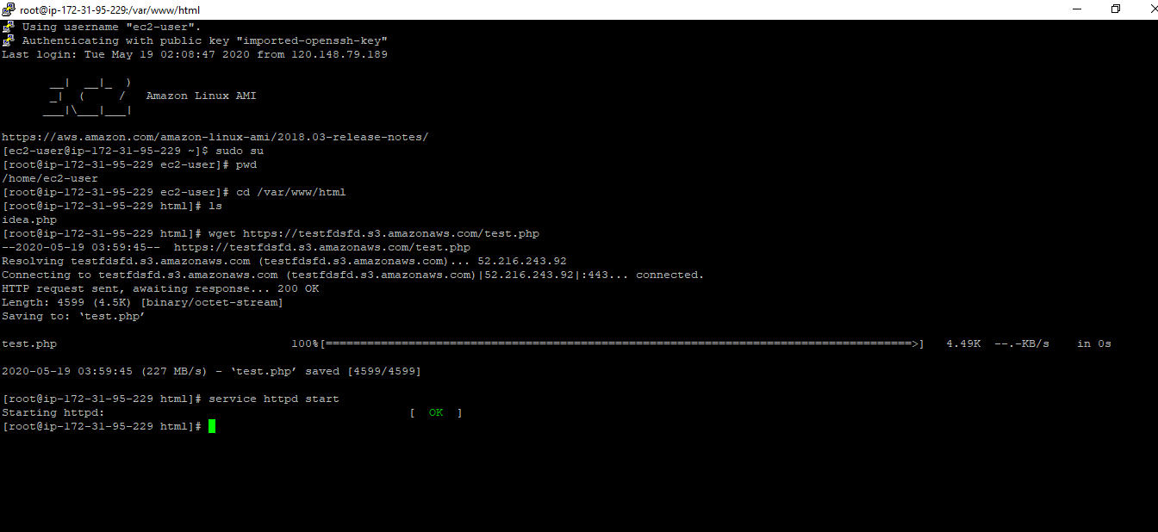

Here we go to root user, move the directory to /var/www/html , upload the files with get and run the service httpd

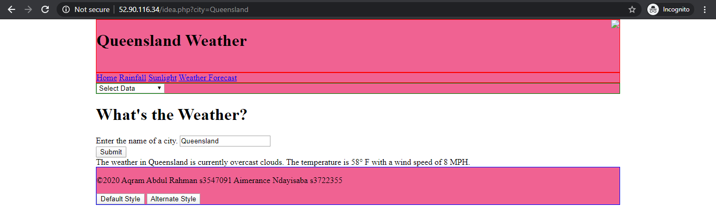

We copy the ip address of the EC2 instances and run it in another browser to see the end result

Here we can navigate through different links to see other weather api’s

Also, we put the city that we want and what temperature measurement they use. In our case we put Queensland.

Once inputted we get the current weather of Queensland through OpenWeatherMap API

Conclusion

Although many of the desired features did not make it into the final build, the end result is successful. This project had many unexpected problems some of which did not get resolved. The API was more difficult to work with than expected which slowed down progress significantly.

We are not able include more aws features due to the nature of the website and the data we were able to gather. There was also more to learn in a short period of time hence we were not able include as many cloud services. The major problem we faced was working in a group online where we not used to work. Having the whole course being offered online it was often hard to find the right time for both us to work, it was hard to understand what we are expected of since we could not ha e a face to face conversation and ask the tutor or the lecture what exactly we should produce and also most of the questions asked in the discussion board where often not answered and they were it was done a bit later than expect or the answer did not specifically answer the question.

References

Step 2 creating a website

-created a base website through w3schools

Step 3 creating a link to putty and the terminal to install apache

ref: https://www.liquidweb.com/kb/install-apache-2-ubuntu-18-04/

ref: https://www.youtube.com/watch?v=hOYg-ClP84g

ref: https://linuxconfig.org/how-to-install-or-upgrade-to-php-7-on-centos-linux-server

Step 4 API

ref: https://stackoverflow.com/questions/33302442/get-info-from-external-api-url-using-php

ref:https://www.youtube.com/watch?v=BuX3okqs9KI

ref:https://www.codeofaninja.com/2017/02/create-simple-rest-api-in-php.html

-The API used is from openweathermap (https://openweathermap.org/api)

Signed Contribution Agreement

Weather Analytics

Aqram/Aimerance

|  |  |
| --- | --- |
| Student Name: Aqram Abdul Rahman | Student Name: Aimerance Ndayisaba |
| Student ID: s3547091 | Student ID: s3722355 |
| Contributions:   * Research * Coding * Deploying | Contributions:   * Research * Coding * Deploying |
| Contribution Percentage: 50% | Contribution Percentage: 50% |
| *By signing below, I certify all information is true and correct to the best of my knowledge.*  Signature:  Aqram Omar Abdul Rahman  Date: 22/05/2020 | *By signing below, I certify all information is true and correct to the best of my knowledge.*  Signature:  Date: 22/05/2020 |